Homeostasis
For the following homeostatic mechanism, identify the various parts.

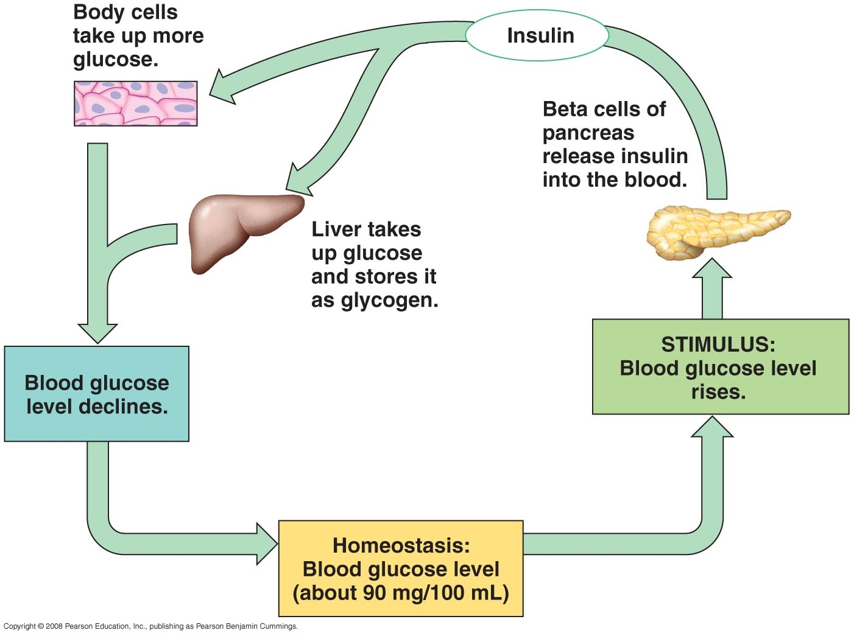

Set Point
Stimulus
Receptor
Integration Center
Effector
Response
Negative or Positive Feedback
For the following homeostatic mechanism, identify the various parts.

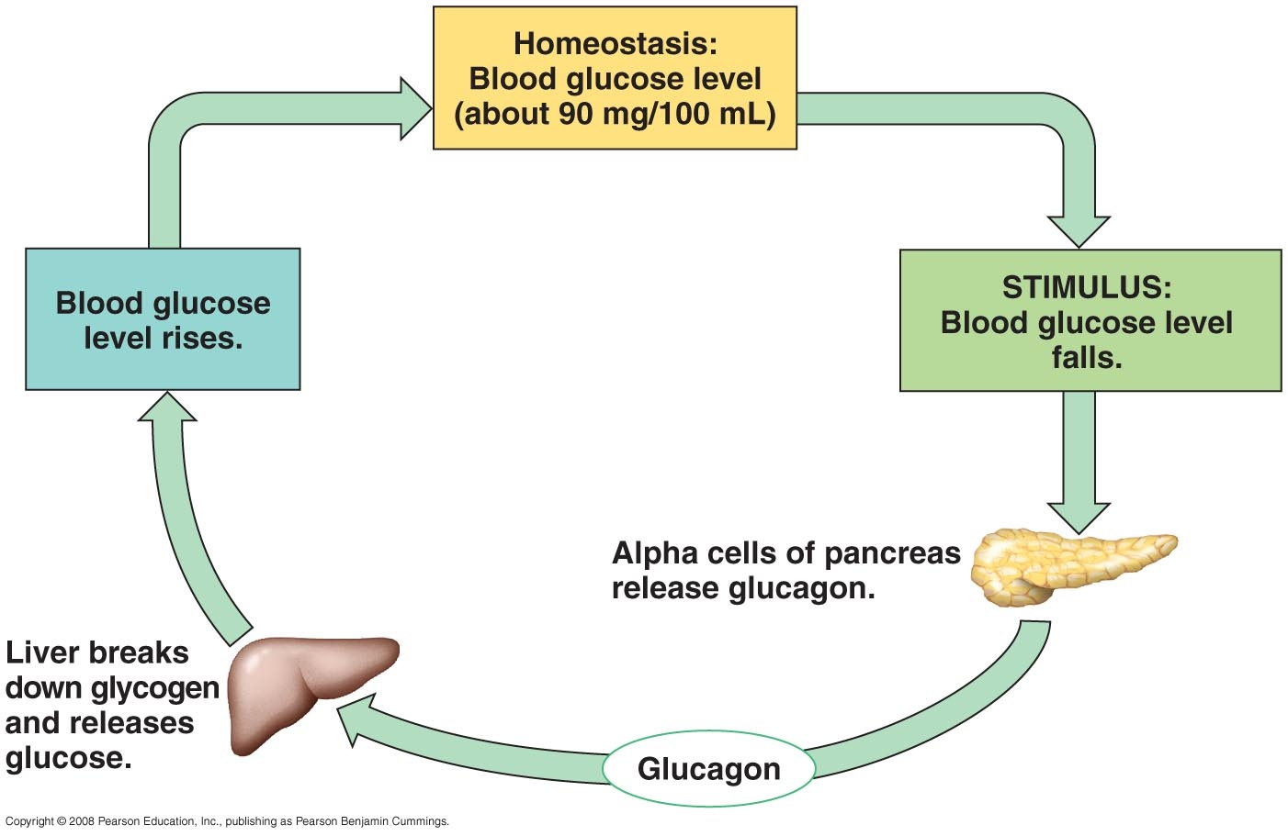

Set Point
Stimulus
Receptor
Integration Center
Effector
Response
Negative or Positive Feedback
Countercurrent Exchange

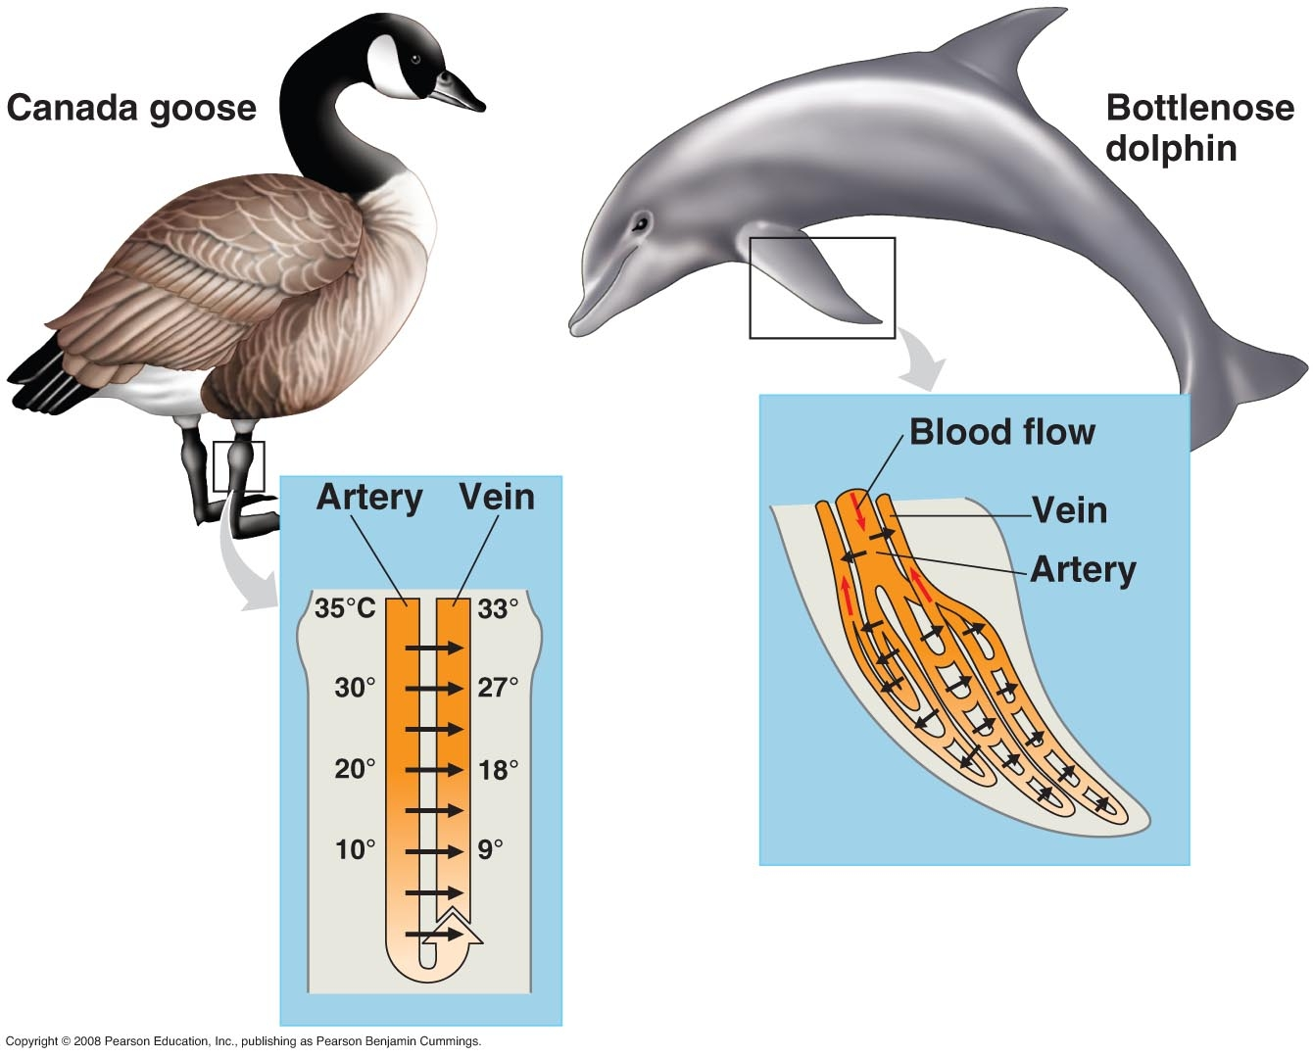

Venous Blood Arterial Blood
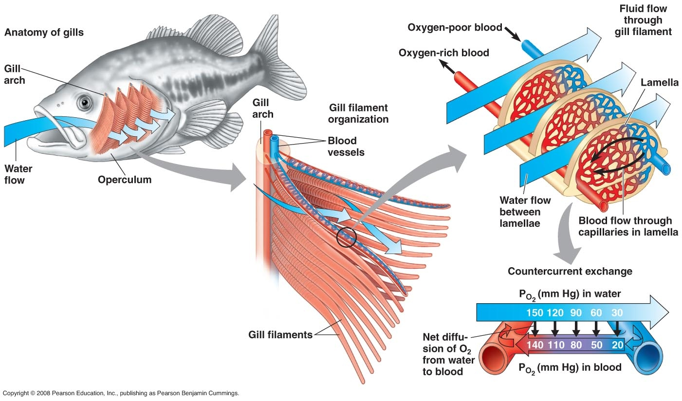

Water Flow Over Gills
Blood Flow Through Capillaries

